- Current Code Deployment process:
Step 1:
- Commit source code to (ics-dpm-di-lambda) https://git.devops.broadridge.net/ICS-DPM/ics-dpm-di-lambda
- So here git a version will generate. Lets - 1215cd1a
Step 2:
- Build in local and push generated jar to (ics-dpm-pp-dockerfiles) https://git.devops.broadridge.net/ICS-DPM/ics-dpm-pp-dockerfiles/-/tree/feature/dpm-kafka-producer
- So here another new git version will generate. Lets - 7d8134dc
- Hence my actual source code version (1215cd1a) and jar version (7d8134dc) are different.
Step 3:
- Execute Jenkin Job to build docker Image.
https://jc-dev3.devops.bfsaws.net/job/ICS-DPM/job/ICS-DPM-docker-build-b228/
- Here we should take care of all below input parameters without mistake.
Parameters:
GIT_SOURCE_URL - git@git.devops.broadridge.net:ICS-DPM/ics-dpm-pp-dockerfiles.git
SOURCE_BRANCH - < Enter branch as per Image to be build>
IMAGE_NAME - < Enter ImageName as per container>
- From Jenkin’s consol output Find out and copy build Version : 7d8134dc

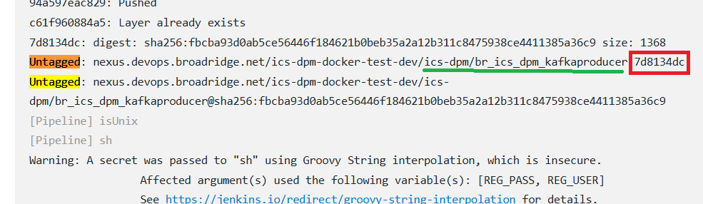
Step 4:
- Execute Jenkins job to Promote Docker Image to JFrog : https://jc-dev3.devops.bfsaws.net/job/PROMOTION/job/Promote_Docker_Image/
- Here we should take case all below input parameters without mistake.
Parameters:
SOURCE_DOCKER_REPOSITORY - ics-dpm-docker-test-dev
NONPROD_IMAGE_PATH - ics-dpm/<ImageName>:<Image Tag>
Step 5:
- Execute Jenkins job for Copy Container Image to ECR:
- Dev: https://jenkins-edw-dev2.devops.broadridge.net/job/CSG/job/ICS-DPM/job/copy-container-image-to-ecr-workaround/
- QA/UAT/PROD: https://jenkins.jenkinsha.ssprd.bfsaws.net/job/CSG/job/ICS-DPM/job/copy-container-image-to-ecr/
Step 6:
- Execute Jenkins Job to Deploy into AWS ECS (Terraform Job):
- Dev: https://jenkins-edw-dev2.devops.broadridge.net/job/CSG/job/ICS-DPM/job/ics-dpm-tf/job/deploy/
- QA/UAT/PROD: https://jenkins.jenkinsha.ssprd.bfsaws.net/job/CSG/job/ICS-DPM/job/ics-dpm-tf/job/deploy/
Parameters:
Module: us-east-1-ecs
ENV Alias:
uev1 → For QA/UAT/PRD
test → For Dev
CUSTOM_TF_VARS:
Please see CONTAINER Deployment Updates for the latest image name values
- Here, we should not mistake mentioning the latest version of CUSTOM_TF_VARS

- Our Expectation
- Git repository for source code would be one. Could be multiple branches.
- Developer should not take care to build Jar file and push to another repository.
- The build version should be handled through pom.xml file.
- Using single pipeline execution, my application would be deployed by avoiding all manual steps.
- If Jenkins build get started first this job will update pom.xml file with new version (numeric version), then start for building artifacts, entry into BR artifact repository, start for deployment etc.
- Jenkins will only allow us to deploy in lower environments from feature (e.g. feature/MyBranch_Name) branch.
- Jenkins will only allow us to deploy in upper environments from release (e.g. release/MyBranch_Name) branch.
- Jenkin will not allow to deploy from master branch, but should merge code from header to master once successful deploy in PROD.
- Jenkins job will not allow us to rebuild same version of artifacts.

Jenkins Build Pre Validation, Update pom.xml with new version, Generate Jar, Update BR Artifacts Repository Deploy

- Create a multi stage pipelines in Jenkins
Creating a multi-stage pipeline in Jenkins is a powerful way to define and automate your CI/CD workflow. You can do this using a Jenkinsfile, which describes the pipeline as code using a Groovy-based DSL.

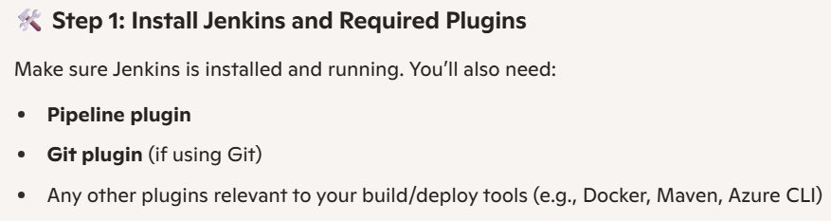
Step 2: Create a Jenkinsfile
This file defines your pipeline stages. Here's a basic example:

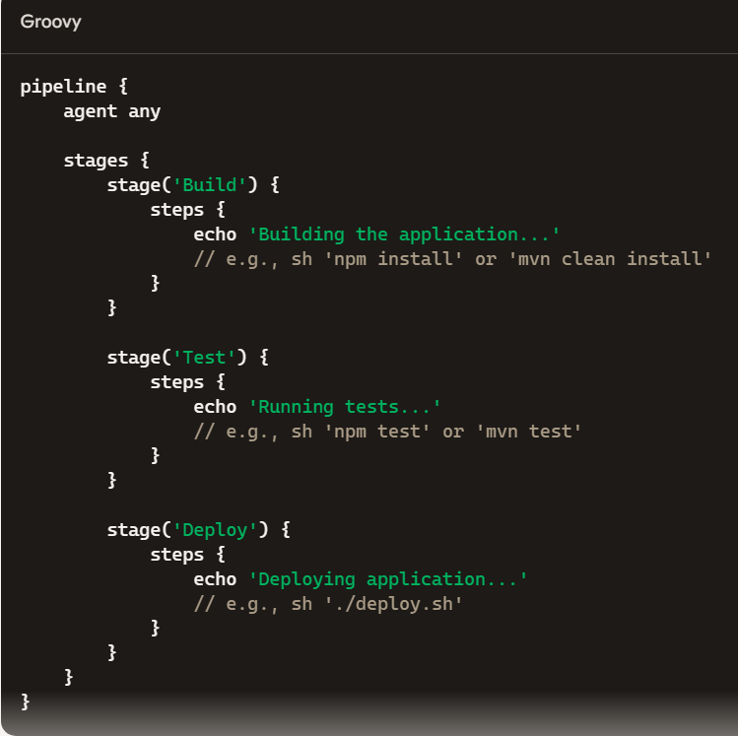

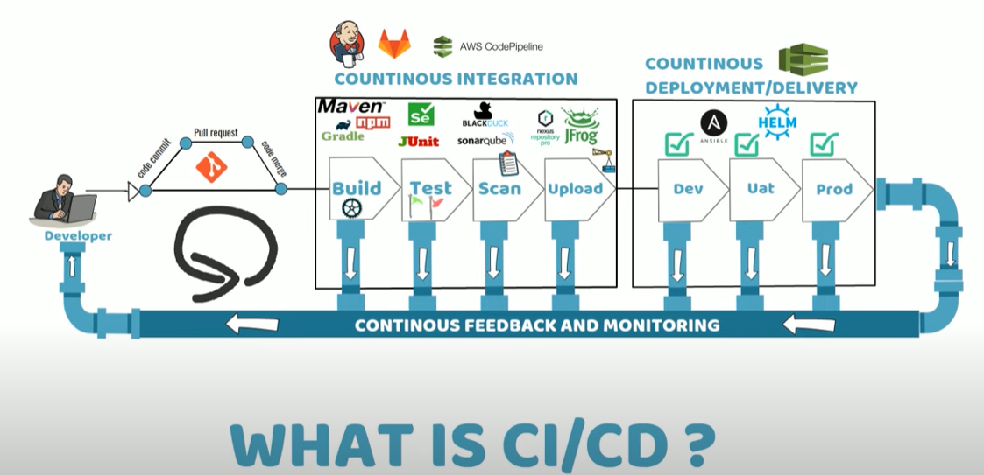
https://www.youtube.com/watch?v=jZYrxk2WMbY
https://www.youtube.com/watch?v=kO7wrtY2b3E
https://www.youtube.com/watch?v=G_UCeeb5EPc

- Jenkins Pipeline:
A suite of plugins that allows defining and managing CI/CD workflows as code, using a domain-specific language (DSL) based on Groovy.
- Jenkinsfile:
A text file containing the pipeline definition, committed to the project's source control for versioning and collaboration.
- Stages:
The fundamental building blocks of a pipeline, representing sequential steps like build, test, and deploy.
- Pipeline-as-Code:
The practice of defining the entire CI/CD process in a script (Jenkinsfile), making it versionable, maintainable, and shareable.
Benefits of using Jenkins CI/CD pipelines:
- Faster Feedback: Rapidly identifies and addresses issues through automated testing.
- Improved Code Quality: Enforces consistent build, test, and deployment processes.
- Increased Efficiency: Automates manual tasks, freeing up developers for more strategic work.
- Reduced Errors: Minimizes human errors associated with manual processes.
- Enhanced Collaboration: Pipelines can be shared and reviewed as code.

feature/My_Branch headers/My_Branch

